Gathering User Views on Text to Speech Language Switching

Introduction
DAISY Consortium is developing guidance on how to include more than one languages in a document in a way that is most useful for people who use assistive technologies. We will show some different experiences and are interested in your reactions and preferences.
We have prepared three paragraphs that tell a short story using two languages.
My grandmother kept her letters in a biscuit tin on the kitchen shelf. When I was small, she would tap the lid and say, “Chaque lettre est une petite porte.” Every letter is a small door. I only understood after she died, when I opened the tin and found an envelope with my name on it.
Ma chère enfant, si tu lis ces mots, c’est que je ne suis plus là pour te les dire. Ne sois pas triste trop longtemps. Va voir la mer au printemps, mange du pain chaud, et marche sous la pluie. La vie est courte, mais elle est large. Je t’embrasse.
I read it twice, slowly, the way she used to read to me. Outside, it had started to rain. I put on my coat and went for a walk. At the door, I heard myself whisper, “Merci, grand-mère.”

Example 1: Second language not spoken
In the first example, the voice for the second language was not present on the device, and so the text was not announced. Has this happened to you? What are your thoughts on this scenario?
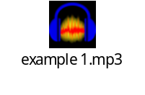

Example 2: Second language spoken using wrong voice
In the second example, the text in the second language is spoken without changing voice.
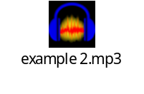

Example 3: Second language spoken using wrong voice, with warning
In the third example, the text in the second language is spoken in correct language, but we get an announcement to let us know what is happening.
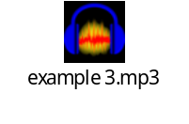
How should assistive technologies behave when no suitable voice is available for the marked language?

Example 4: Second language spoken with correct voice
In the fourth and final example, we hear the voice switching to the second language.
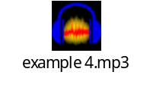
Should assistive technologies announce language changes, switch voices automatically, or provide both options?
In which types of publications does automatic language switching become distracting or reduce listening comfort?
What aspects of language switching behavior should users be able to configure?

